SALES PERFORMANCE QUESTIONS

1. Total Revenue by Product
</> SQL Query
--What is the total revenue generated by each product type?
SELECT
SUM(standard_amt_usd) AS standard_revenue,
SUM(gloss_amt_usd) AS gloss_revenue,
SUM(poster_amt_usd) AS poster_revenue
FROM orders;
Explanation:
This query sums up revenue for each product type. Standard paper generated the highest revenue (almost $10M), followed by gloss, while poster paper had the lowest.
Image Result:
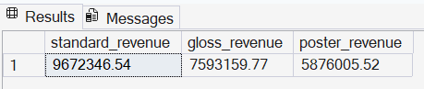
2. Top 10 Orders by Revenue
</> SQL Query
--What are the top 10 orders by total revenue?
SELECT TOP 10
id,
account_id,
total_amt_usd AS total_revenue
FROM orders
ORDER BY total_amt_usd DESC;
Explanation:
This query selects the 10 highest value orders. The result shows the biggest transactions made by customers, highlighting top revenue generating orders.
Image Result:
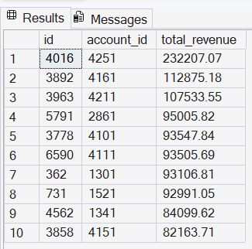

3. Revenue by Region
</> SQL Query
--What is the total revenue by region?
SELECT
r.name AS region,
SUM(o.total_amt_usd) AS total_revenue
FROM orders o
JOIN accounts a ON o.account_id = a.id
JOIN sales_reps s ON a.sales_rep_id = s.id
JOIN region r ON s.region_id = r.id
GROUP BY r.name;
Explanation:
This query calculates total revenue per region. The result shows which region generates the most sales and which performs the least.
Image Result:
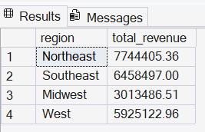

CUSTOMER ANALYSIS QUESTIONS
4. Top 10 Customers
</> SQL Query
--Who are the top 10 customers by total revenue?
SELECT TOP 10
a.name AS customers,
SUM(o.total_amt_usd) AS total_revenue
FROM orders o
JOIN accounts a ON o.account_id = a.id
GROUP BY a.name
ORDER BY total_revenue DESC;
Explanation:
This query identifies the top 10 customers based on total spending. It shows the most valuable customers contributing the highest revenue.
Image Result:
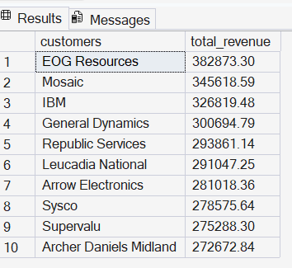

5. Customers per Sales Rep
</> SQL Query
--How many customers does each sales representative manage?
SELECT
s.name,
COUNT(a.id) AS total_customers
FROM accounts a
JOIN sales_reps s ON a.sales_rep_id = s.id
GROUP BY s.name;
Explanation:
This query counts customers handled by each sales rep. It shows workload distribution across the sales team.
Image Result:
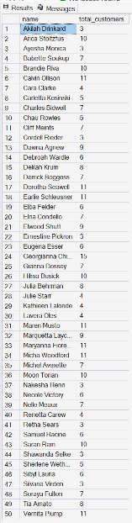

6. Customer Revenue Tier
</> SQL Query
-- Categorize customers by total revenue tier (High/Medium/Low)?
SELECT
a.name,
SUM(o.total_amt_usd) AS total_spent,
CASE
WHEN SUM(o.total_amt_usd) > 100000 THEN 'High'
WHEN SUM(o.total_amt_usd) > 50000 THEN 'Medium'
ELSE 'Low'
END AS customer_tier
FROM orders o
JOIN accounts a ON o.account_id = a.id
GROUP BY a.name;
Explanation:
This query groups customers into High, Medium, and Low spenders. It shows how customers are distributed based on their total spending.
Image Result:
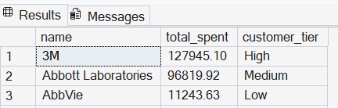
SALES REPRESENTATIVE PERFORMANCE QUESTIONS

7. Revenue by Sales Rep
</> SQL Query
--What is the total revenue generated by each sales representative?
SELECT
s.name,
SUM(o.total_amt_usd) AS total_revenue
FROM orders o
JOIN accounts a ON o.account_id = a.id
JOIN sales_reps s ON a.sales_rep_id = s.id
GROUP BY s.name;
Explanation:
This query calculates revenue per sales rep. It shows which sales reps are performing best.
Image Result:
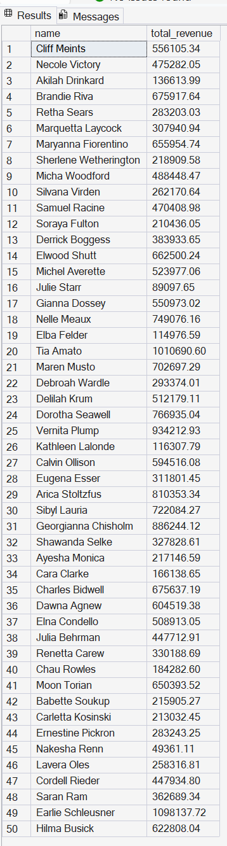

8. High Performing Sales Reps
</> SQL Query
--Which sales reps have generated more than $500,000 in total revenue?
SELECT
s.name,
SUM(o.total_amt_usd) AS total_revenue
FROM orders o
JOIN accounts a ON o.account_id = a.id
JOIN sales_reps s ON a.sales_rep_id = s.id
GROUP BY s.name
HAVING SUM(o.total_amt_usd) > 500000;
Explanation:
This query filters sales reps with revenue above $500,000. It highlights top performers exceeding the benchmark.
Image Result:
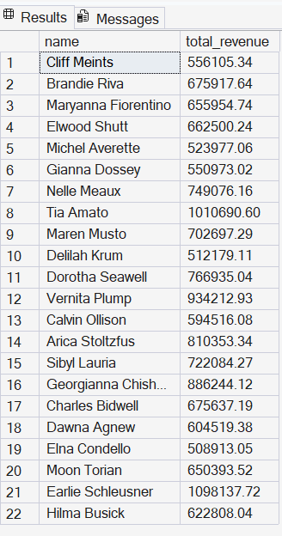
WEB ENGAGEMENT QUESTIONS
9. Web Events by Channel
</> SQL Query
--How many web events occurred through each channel?
SELECT
channel,
COUNT(id) AS total_events
FROM web_events
GROUP BY channel;
Explanation:
This query counts web interactions per channel. It shows which channel drives the most engagement.
Image Result:
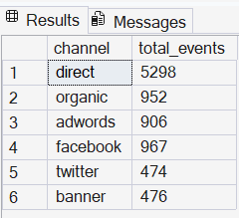

10. Accounts with Most Web Activity
</> SQL Query
--Which accounts have the most web activity?
SELECT TOP 10
a.name,
COUNT(w.id) AS total_events
FROM web_events w
JOIN accounts a ON w.account_id = a.id
GROUP BY a.name
ORDER BY total_events DESC;
Explanation:
This query identifies customers with the highest online activity. It highlights highly engaged users.
Image Result:
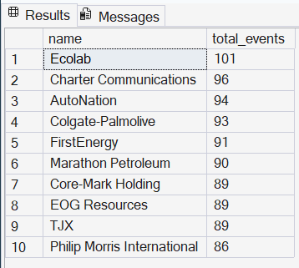

11. Web Engagement vs Orders
</> SQL Query
-- Which customers have high web engagement but low order frequency?
SELECT TOP 10
a.name,
COUNT(DISTINCT w.id) AS web_events,
COUNT(DISTINCT o.id) AS total_orders
FROM accounts a
LEFT JOIN web_events w ON a.id = w.account_id
LEFT JOIN orders o ON a.id = o.account_id
GROUP BY a.name;
Explanation:
This query compares web activity with orders. It shows customers who engage online but may not be purchasing much.
Image Result:
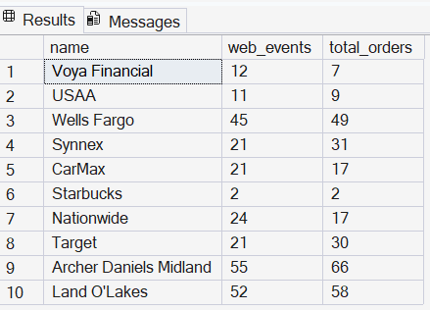

12. Customer Contact List
</> SQL Query
--Create an email list with formatted customer names and clean website domains?
SELECT
name,
LOWER(REPLACE(name, ' ', '')) + '@' +
REPLACE(website, 'www.', '') AS email_address
FROM accounts;
--Create an email list using customer names and website domains
Explanation:
This query creates an email list by combining customer names with their website domains. It formats the name by converting it to lowercase and removing spaces, then attaches the cleaned website to form an email.
The result shows a structured email format for each customer, making it easy for the business to generate contact emails for communication or marketing purposes.
Image Result:
